171 North Second Street Pike, Churchville, PA 18966-1143
Tel (215) 354-0929 ● Fax (215) 354-0930 ● Email: sasha@russianmissions.org
www.russianmissions.org
June 2005
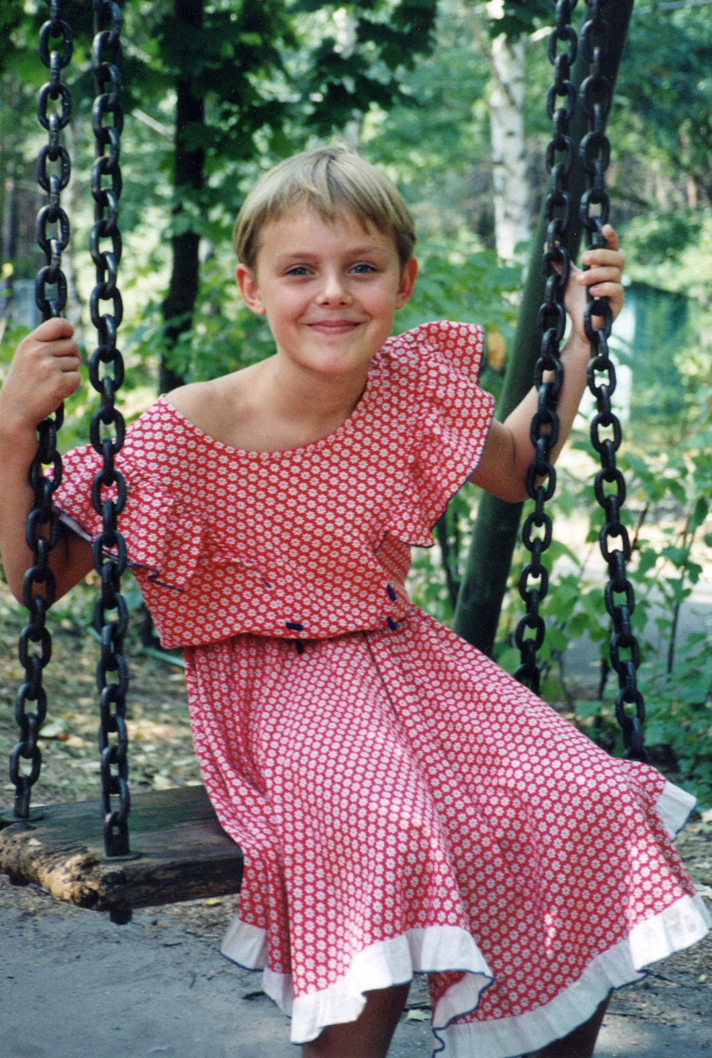
Dear Friends,

Won’t you provide a ray of sunshine into the lives of so many children who have experienced one cloudy day too many.

Take a second to remember those playful summer days of youth:
Outside games until sundown
The joy of splashing water
Figuring out what object a cloud resembled
The scents of flowers and fresh rain

Summer should be a magical time to enjoy everything outdoors that He has provided, and with your support our at-risk children can do just that.

Through Safe Haven Summer Camps, Russian Missions provides activities for needy, at-risk Russian children that enrich the spirit and stimulate the senses, while enjoying the companionship of Christian pastors and trained counselors.

Summer is coming! A time for rejuvenation and new growth! Come along on our journey—there’s always room for one more!

One Traveler’s Story - “Shattered Life Made New”

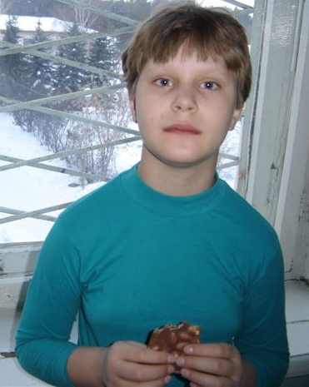
Masha’s life was shattered, with no one to pick up the pieces. In her early childhood years, when she most needed love and acceptance, Masha felt anything but secure. Mistreatment had plagued her daily existence. She was born in the Ukraine to parents who were in their 40’s. By the age of two, her mother’s schizophrenia created on-going havoc within the home. Confinement to a mental hospital was the only resolution. Her Dad’s intention was to “move away from bad memories” so he up-rooted Masha and settled in Tyumen. Without God’s hope and love, her Dad became embittered and paid very little attention to his unkempt daughter. How desperately she longed for someone to reach down and pull her out of her despair! But, there was no one.

Russian Missions came upon 11 year old Masha last year. Her history included being a runaway. Police would find her in train stations or subways always looking for a way to get back to her Mommy.

At this low point, Masha was given a scholarship to our camp. Her first day of camp was filled with apprehension—both for Masha and the staff— amidst bouts of loud crying, Masha’s inappropriate actions included: hiding, non-speaking, and lashing out. Our counselors were challenged by Masha’s needs. This raggedy child had never been taught basic life skills: to brush her teeth, comb her hair or wash.

Our first break came through a warm meal. She delighted in its simple tastes and textures and, most importantly, unlimited portions...then a smile. For the first time, Masha began to feel God’s love. Counselors provided her with: her first toothbrush, toothpaste, soap, comb, towels, etc.) and quickly she learned about personal hygiene. By the end of her encampment, she had put her trust in Jesus; the loving Lord who took control of her life and filled her with divine peace. What a refreshing change from her shattered childhood!
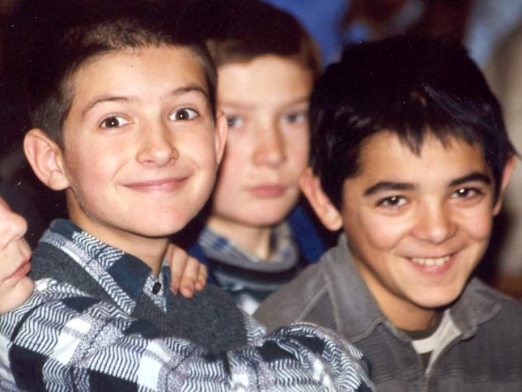
Today, this young child is attending Sunday school and ministering to her Father, sharing Christ’s redeeming hope with him. When one of our staff members encounters Masha at church, the question is always the same: When will summer camp start again?

We are incredibly blessed to be part of the process of drawing these little ones to the God who loves them so much. There are Safe Haven Summer Camps throughout Russia that provide a Christ-centered, Bible-based outdoor program designed to help children and youth learn about Jesus Christ and how to make him Lord in every aspect of life. While for many it will be their first time away from home, what is most important is that it’s their first time experiencing the never-failing love of Jesus. That is why I ask you to join me in sending one or more of these precious little ones to camp.

2005 Summer Camp Programs (June through August)
$50 | Scholarship for one child for one week
$100 | Scholarship for two children for one week
$125 | Provisions for a program
$150 | Transportation costs for a program
$500 | Scholarship for 10 children

Check out our website: www.russianmissions.org for more information on our goals and ministry. Please help as you can and as the Lord leads today. We are thankful for whatever you can do to help.

Your Brother in the Lord,
Rev. Alexander Yuchkovski
Sasha
Director, Russian Missions

P.S. Russian Missions is a not-for-profit religious, charitable and educational corporation and is federally tax-exempt according to section 501(c)(3) of the IRS code. Contributions to this ministry are tax deductible to the full extent of the law.

